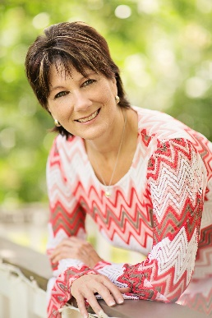
JANNA VALENCIA BIOGRAPHY

Janna Valencia is a 30 year veteran of business growth and management. She specializes in helping people identify their dreams and make them reality.

She was born and raised in a small East Texas town learning the values of hard work at a young age. Having aspirations to become a difference maker in the world, she began her ascent to entrepreneurism through the corporate world of retail. She started her career in sales, learning essential skills of business success, and moved into management, increasing her skills to include marketing, operations, administration and leadership.

She has built successful businesses, achieving her dreams and realized that the experience she gained is applicable in everyone’s life, personally and professionally. She developed a desire to share what she has learned with others, helping them learn that they can achieve everything in life they want.

She now uses her years of experience in the “hard knocks” of life, corporate training, business ownership, and her Ziglar Legacy Certification to inspire and train others to make their dreams a reality.

She is firm believer that it does not matter who you are, where you have been, or what you have been through, you can have everything in life you want.

“Achieving your life’s dreams are nothing more than a decision to make it happen, a determined reason why you want it, a good plan, and a lot of fortitude.” Janna Valencia

Janna is an author of the book, The Road to Healing, Turning Yesterday’s Pain in to the Stepping Stones that Lead to Your Destiny and coauthor of Dare to be a Difference Maker.

You may contact Janna through email at janna@jannavalencia.com. Visit her website at JannaValencia.com

